V25
Importing The SystmOne Allowed List
SystmOne Manuals

Contents
Current Version 1
Questions or Issues 1
Save The File 1
Within SystmOne 2
On the Allowed List 4

Current Version
Please note that this manual will cover version 25 of the NHS NWL Allowed list published on 22nd April 2026.

Questions or Issues
Should you have any questions or issues when importing the new allowed list, please contact the NHS North West London ICT Service Desk via the NWL IT Self Service telephone 020 3350 4050 or email Nwlccg.servicedesk@nhs.net

Save The File
From the shared list icon below “v25.shr” , Right click on the file above and click Copy
Go to your Desktop (or a specific folder/ shared drive you would like to save the document in), Right Click anywhere and Paste

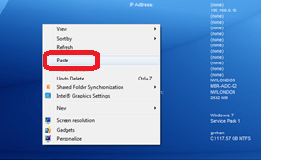

Within SystmOne
Open SystmOne, click Setup> Users and Policy> Share in Rules

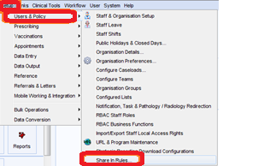

Click on Custom, then “Import”

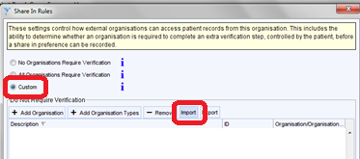
Click ‘OK’
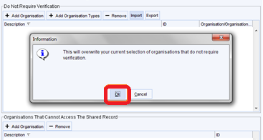

Find the file on your desktop (or relevant area saved), double click on it
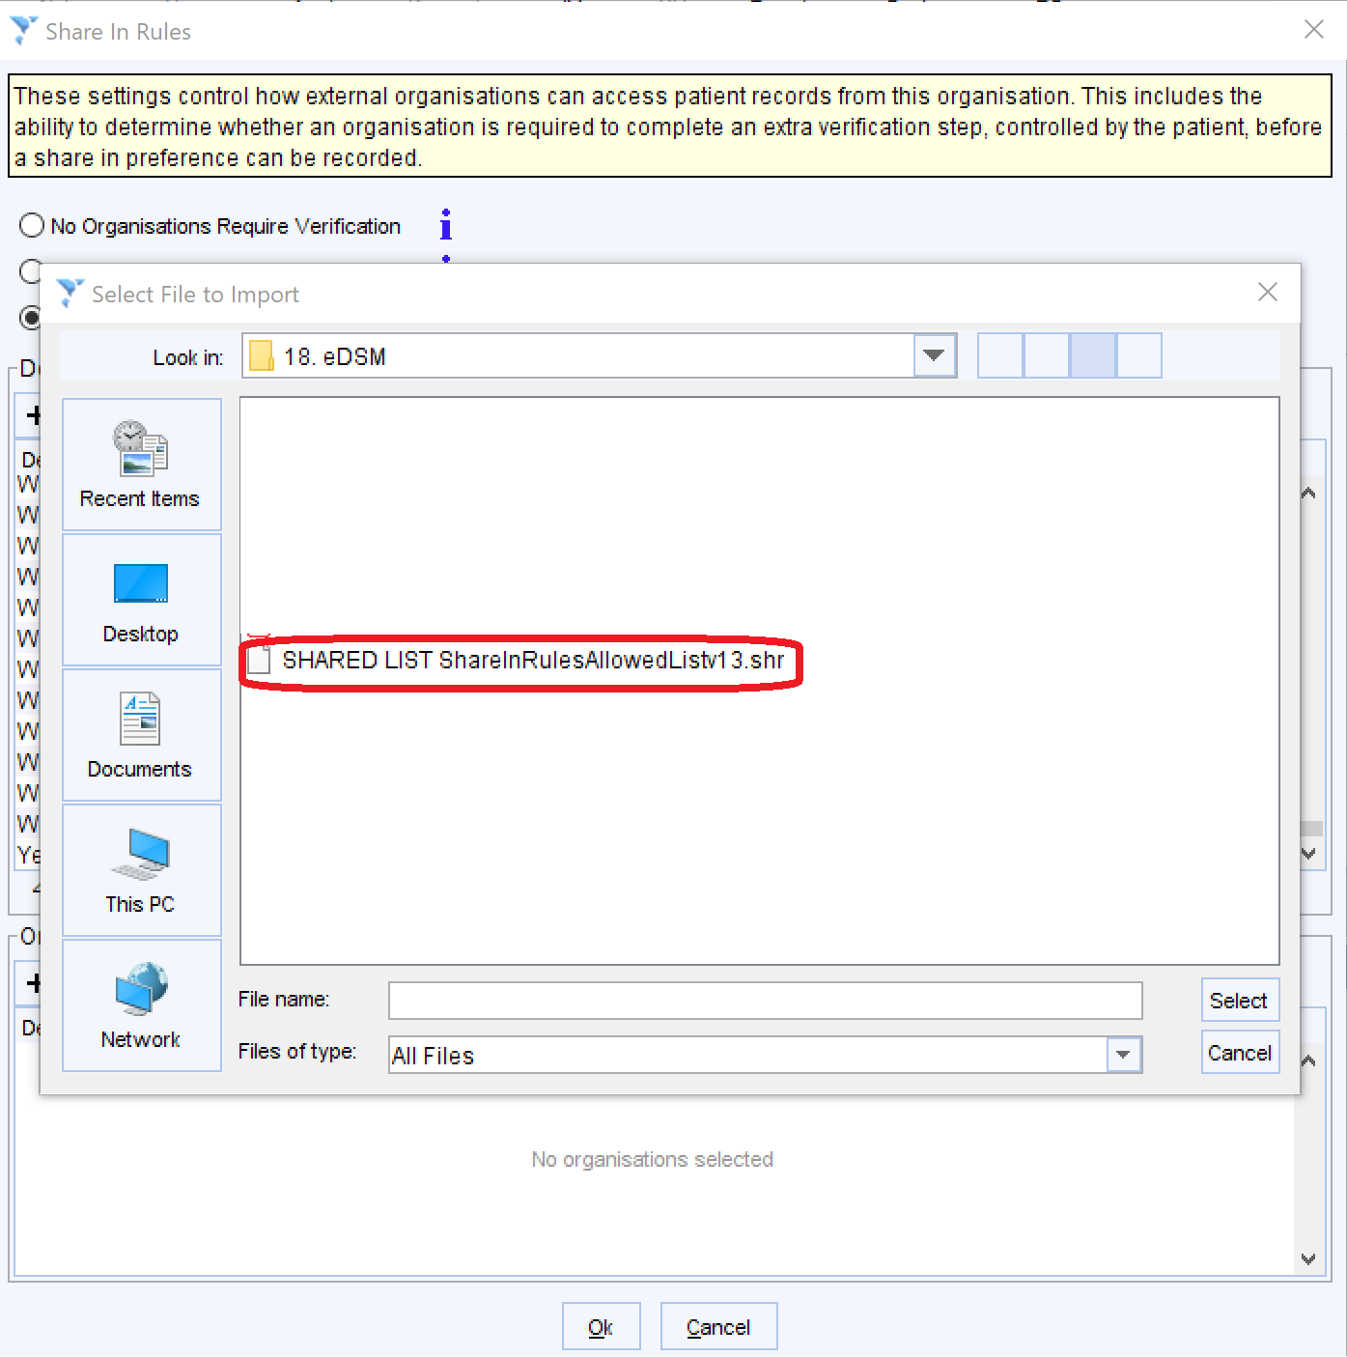
This should upload all the units into the ‘allowed list’
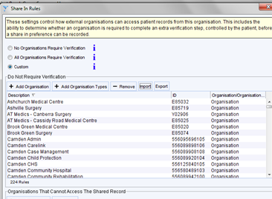
Once you are happy with the list, Click ‘OK’ at the bottom of the screen

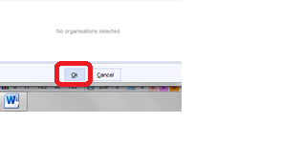

On the Allowed List
Please see the list of Organisations that have signed up to the NHS North West London Data Sharing Agreement and will therefore form part of the ‘allowed list’ along with practices and PCN units within NHS North West London.

Name of Unit | Unit ID
(ARCHIVED) HRCH SWL Health and Wellbeing Sutton and Merton | 555652399106
Acton Lane Medical Centre | E85687
Acton PCN | U81324
Acton Town Medical Centre Cared for by Crown Street Surgery | E85617
Allenby Clinic | E85105
Amber Valley Childrens Community Services | 559919737106
ARC Hounslow | 564151088108
Ashchurch Medical Centre | E85032
Ashville Surgery | E85719
AT Medics - Barlby Surgery | Y01011
AT Medics - Canberra Surgery | Y02906
AT Medics - Cassidy Road Medical Centre | E85025
AT Medics - Kings Road Medical Centre | E87063
B & I Extended Hours HUB | Y06718
Bath Road Surgery | E85716
Bayswater Medical Centre | E87682
Bedfont Surgery | E85697
Belgrave Medical Centre | E87753
Belmont Medical Centre | E85049
Blue Wing Family Doctor Unit | E85058
Boileau Road Surgery | E85694
Brent Dermatology | 555999269104
Brent Physio/MSK | 555999213107
Brent Stroke ESD Service | 557429763107
Brentford Family Practice | E85735
Brentford Group Practice | E85605
Broadmead Surgery | E85715
Brompton Health PCN | U05784
Brompton Medical Centre | E87746
Brook Green Medical Centre | E85020
Brunswick Surgery | E85091
Camden 0-19 | 556095002106
Camden Carelink | 556089898106
Camden Child Protection | 556089920104
Camden Children Looked After - CLA | 556095571105
Camden CHS | 556125840105
Camden Community Rehabilitation | 556089942100
Camden Complex Care Nursing | 556089908108
Camden Continuing Care | 556089950101
Camden District Nursing | 556089955106
Camden Governance | 556095702103
Camden Heart Failure | 556095529102
Camden Integrated Children Services | 556095547104
Camden Overnight Nursing | 556095577101
Camden Palliative Care | 556095599107
Camden Phlebotomy | 556095610102
Camden Podiatry | 556095614106
Camden Rapid Access Services | 556095629103
Camden Respiratory | 556095638104
Camden School Nursing | 556095645103
Camden Staying Steady Groups | 556089960103
Camden Stroke & Neurology | 556095651102
Camden Telehealth | 556095658109
Camden Transfer of Care Hub | 556095696105
Camden Twilight | 556095662105
Camden Wheelchair Service | 556095676101
Care Co-ordination Service (CCS) | 558743203106
Carlton Surgery | E85024
Cavendish Health Centre | E87745
Central & West London Community Cardiology & Respiratory Service | 555467890109
Central London Extended Hours | Y05686
Chelsea Medical Services | E87048
Chepstow Gardens Medical Centre | E85023
Chesterfield Childrens Community Services | 559919950106
Chestnut Practice | E85059
Chiswick Family Doctors Practice | E85625
Chiswick Family Practice - Drs Bhatt and Szyszko | E85130
Chiswick Health Practice | E85030
Chiswick Medical Practice | E85693
Chiswick Primary Care Network | Y06826
Churchfield Road Surgery | E85640
CLCH Adults - Homeless Health Service | 403376083560
CLCH Adults Barnet Planned -Community Nursing | 705324883564
CLCH Adults Barnet Planned -Therapy/Falls/ESD/SLT | 645552538565
CLCH Adults Community Neuro-Rehabilitation | 868588503565
CLCH Adults Community Nursing - Central London CCG | 788715520565
CLCH Adults Community Nursing - H&F CCG | 737651470566
CLCH Adults Community Nursing - West London CCG | 401748428562
CLCH Adults Diabetes - Barnet | 551171045562
CLCH Adults Diabetes - Inner | 676043282562
CLCH Adults Falls - Inner | 576261324569
CLCH Adults GPWSI | 282547051569
CLCH Adults Health Improvement | 546480104563
CLCH Adults Heart Nursing | 864422626563
CLCH Adults MSK | 311116161564
CLCH Adults Night Nursing - Inner London | 562260618565
CLCH Adults Nutrition & Dietetics | 200234112569
CLCH Adults Parkinson's | 244778711568
CLCH Adults Podiatry & Podiatric Surgery | 166365450567
CLCH Adults Respiratory/COPD - Barnet | 554411553569
CLCH Adults Respiratory/COPD - Inner | 283335078566
CLCH Adults SPA Inner | 553104485568
CLCH Adults Specialist Bladder & Bowel | 252007661561
CLCH Adults SPOR Hammersmith & Fulham | 163080361567
CLCH Adults SPOR Kensington & Chelsea | 345618318561
CLCH Adults SPOR Westminster | 167823602567
CLCH Adults Tissue Viability | 516541131566
CLCH Adults Urology | 288605866566
CLCH Barnet Integrated Childrens Services | 486582431566
CLCH Barnet Looked After Children | 580896890100
CLCH Brent Bedded Neuro Rehabilitation | 578707513100
CLCH Brent Bladder and Bowel Service | 578706996102
CLCH Brent Children's Specialist Services | 578707339108
CLCH Brent Community Nursing | 578707104105
CLCH Brent Diabetes | 578707164108
CLCH Brent Integrated Rehab and Reablement | 578707388108
CLCH Brent Looked After Children | 578707271108
CLCH Brent Nutrition and Dietetics | 578707292103
CLCH Brent Podiatry | 578707317102
CLCH Brent Respiratory and Pulmonary Rehab | 578707379107
CLCH Brent School Nursing | 556634662109
CLCH Brent Special School Nursing | 556634690103
CLCH Brent Tissue Viability | 578707437107
CLCH Brent Twilight Community Nursing | 578707461108
CLCH CH Brent Child Health | 561045953109
CLCH CH Brent Health Visiting | 560870185107
CLCH CH Community Nursing & Complex Care | 256218111563
CLCH CH Eye Service | 463510130560
CLCH CH FNP | 475483434563
CLCH CH Haemoglobinopathy | 134204761560
CLCH CH Hammersmith & Fulham 0 - 19 | 374077448560
CLCH CH Inner CYPOT | 587161107566
CLCH CH Kensington & Chelsea Health Visiting & LAC | 246057534561
CLCH CH Nutrition & Dietetics | 466803385569
CLCH CH SLT | 473138726566
CLCH CH Triborough Looked After Children Service | 590912000106
CLCH CH Westminster Health Visiting & LAC | 427736670568
CLCH Child Development Service | 664624125566
CLCH Child Health Information Hub | 386246463569
CLCH Ealing Child Health Unit | 564856780103
CLCH Ealing Health Visiting | 564856342102
CLCH Ealing School Nursing | 564856742106
CLCH Harrow Palliative Nursing | 578707483104
CLCH Harrow School Aged Imms (formerly inc SN) | 557228426102
CLCH Hounslow School Aged Imms (formerly inc SN) | 556486495101
CLCH Inner Bedded Services | 564866572568
CLCH Medicines Management | 560927592102
CLCH My Care My Way | 567297883103
CLCH Outer Bedded Services | 518172417561
CLCH Pembridge Hospice | 562519668100
CLCH Richmond & Wandsworth Child Health Unit | 562683792107
CLCH Richmond Health Visiting | 562396405109
CLCH Richmond School Nursing | 556251602103
CLCH Safeguarding | 516552001567
CLCH Walk In Centre (Edgware CH) | 466788786567
CLCH Walk In Centre (Finchley MH) | 365235105563
CLCH Walk In Centre (Parsons G) | 155156550560
CLCH Walk In Centre (Soho) | 501216572567
CLCH Walk In Centre (St Charles H) | 678578083563
CLCH Wandsworth 0 - 19 | 562476271108
Clifford House Medical Centre | E85071
Clifford Road Surgery | E85696
Cloister Road Surgery | E85680
CNWL - Community Living Well | 557901974104
CNWL Addictions | 563756277100
CNWL Adults CIS Hammersmith and Fulham | 559284779108
CNWL Adults CIS Kensington and Chelsea | 559284787108
CNWL Adults CIS Westminster | 559284809104
CNWL Harrow & Hillingdon Children Looked After - CLA | 556088069101
CNWL Health & Justice Services | 563756267108
CNWL Hillingdon Rapid Response & Phlebotomy | 556088066108
CNWL K&C School Nursing | 560504784107
CNWL London Brent Adults and Rehab | 563756087100
CNWL London CAMHS and CAMHS Inpatients | 563756161101
CNWL London Eating Disorders and Inpatients | 563756179101
CNWL London Harrow Adults and Rehab | 563756099104
CNWL London Hillingdon Adults and Rehab | 563756113102
CNWL London Inpatients | 563756065104
CNWL London Kensington and Chelsea Adults and Rehab | 563756122103
CNWL London Learning Disabilities and Inpatients | 563756197103
CNWL London MHA | 563756251100
CNWL London OPHA | 563756148103
CNWL London Perinatal | 563756223105
CNWL London Psych Med | 563756202100
CNWL London Specialists | 563756242108
CNWL London Urgent Care Service | 563756230104
CNWL London Westminster Adults and Rehab | 563756135108
CNWL SPOR | 559284650104
CNWL Trust Reporting | 556422676105
CNWL Westminster School Nursing | 560504796101
Colville Health Centre | E87067
Community Heart Failure Service | 566348274104
Connaught Square Practice | E87037
Connect Health - H&F MSK | 558071487103
Corfton Road Surgery | E85123
Covent Garden Medical Centre | E87045
Cranford Medical Centre | E85052
Crawford Street Surgery | E87070
CRH Children Continence | 566406668104
Crompton Medical Centre | E87052
Crosslands Surgery | E85114
Crown Street Surgery | E85019
DCHS Children's Services Shared Hub | 560736543107
DCHS Specialist Children's Services | 584339586104
Derbyshire Children's Continence Service Level 2 | 566406713109
DMC Healthcare Dermatology | 563500862107
Dormers Wells Medical Centre | E85682
Dr Ahmed - Queens Park Health Centre | E87755
Dr H Nay Lin & Partner | E85726
Dr Jefferies & Partners, 292 Munster Road | E85029
Dr N Issac's Surgery | E85109
Dr Pauline Lai Chung Fong - Queens Park Health Centre | E87735
Dr Shakarchi's Practice | Y02260
Dr Sood's Practice | E85018
Dr Srikrishnamurthy | E87751
Drs Uppal & Partners | E85624
Ealing Adult and Neurological Rehabilitation | 566556188101
Ealing Bladder and Bowel Service | 566556171102
Ealing Care Coordination | 566816503105
Ealing Children's Services | 566556245100
Ealing Community Cardiology | 556674235105
Ealing Community Nursing | 566556085107
Ealing Diabetes | 566556148102
Ealing GP Access Centres | Y05696
Ealing Hospital Rehabilitation Services | 555999223109
Ealing Learning Disabilities | 566556162101
Ealing Looked After Children & Care Leavers | 566556254102
Ealing Meadow House Palliative Care | 560925834100
Ealing Network PCN | U95154
Ealing Nutrition/Dietetics | 566556214103
Ealing Old Community Services | 555999407101
Ealing Park Health Centre | E85657
Ealing Phlebotomy | 566556288102
Ealing Physiotherapy / Msk | 566556211100
Ealing Podiatry | 566556205102
Ealing Rapid Response | 566842867109
Ealing Respiratory Team | 566556155102
Ealing Short Term Rehab & Reablement | 566842883109
Ealing Speech And Language Therapy | 566556199104
Ealing TB / Ealing SLT Voice | 555999253106
Ealing Tissue Viability | 566556224105
Ealing Urgent Care Centre | AD915
Earl's Court Health & Wellbeing Centre | Y03441
Earls Court Medical Centre | E87047
Earls Court Surgery | E87750
Eastmead Surgery | E85046
ECP - Clayponds In-Patient | 566556277109
Elm Trees Surgery | E85112
Elmbank Surgery | E85088
Elthorne Park Surgery | E85628
Emperor's Gate Surgery | E87043
Enhanced Community Cardiology Services | 566488823104
Enhanced Health Checks for Grenfell | 578695204109
Erewash Children's Community Services | 559920023105
Featherstone Road Health Centre | Y02342
Feltham & Bedfont Extended Hours Hub | Y06969
Fitzrovia Medical Centre | E87066
Florence Road Surgery | E85122
Fulham Cross Medical Centre | E85649
Gill Medical Practice | E85708
Glebe Street Surgery | E85683
Golborne Canalside Health Centre (Dr Razak) | E87742
Goodcare Practice | E85712
Gordon House Surgery | E85026
GP at hand | E85124
GP Surgery at Acton Gardens | E85075
GPwSI Community Dermatology Service | 567679736105
Grand Union Health Centre | E87637
Great Chapel Street Medical Centre | E87772
Green Practice | E85126
Greenford Avenue FHP | E85051
Greenford Road Medical Centre | E85050
Greenwell PCN | U45703
Grenfell Survivors Respiratory & Paediatrics Monitoring | 566694437103
Grosvenor House Surgery | E85034
Grove Park Terrace Surgery | E85746
Grove Village Medical Centre | E85699
Guru Nanak Medical Centre | E85121
GWR Extended Hours Hub | Y06834
H&F Weekend Plus | Y04831
Half Penny Steps Health Centre | Y02842
Hammersmith & Fulham Centres For Health | Y02589
Hammersmith & Fulham Community Cardiology & Respiratory Service | 557517041101
Hammersmith & Fulham Community Gynaecology Service | 555467753103
Hammersmith & Fulham Partnership | U18398
Hammersmith & Fulham PCN (Central) | U55717
Hammond Road Surgery | E85090
Hanwell Health Centre | E85041
Hatton Medical Practice | E85718
HCH Hounslow Care Together | 588941429106
HCH MSK, Pain Management & Hands Service | 588747902108
HCH NWL Adult SLT, CNRT & Dietetics | 588593446101
HCH NWL Adult Specialist Nursing Services | 588593675105
HCH NWL Childrens PT, OT & SLT | 588593711108
HCH NWL Community Recovery Service | 588593795101
HCH NWL Diabetes Service | 588593815107
HCH NWL District Nursing | 588593824109
HCH NWL Enhanced Dementia Care Service | 588593854106
HCH NWL Falls Prevention & Bone Health Service | 588593882107
HCH NWL Family Nurse Partnership | 588593907102
HCH NWL Health Visiting | 588593927100
HCH NWL Hounslow CLA | 588593941101
HCH NWL Hounslow Comm Paeds | 588593953106
HCH NWL Integrated Community Response Service | 588593976107
HCH NWL Integrated Discharge Hub | 588594000105
HCH NWL Learning Disabilities | 588594016101
HCH NWL Podiatry | 588594039103
HCH NWL School Nursing | 588594056107
HCH NWL SPA | 588594065108
HCH NWL Specialist Childrens | 588594092102
Health Partners at Violet Melchett | E87004
Healthcare Central London PCN Access Hub | U12548
Healthcare Central London PCN Allied Health Hub | U02961
Healthcare Central London PCN LTC Hub | U81960
Healthcare Central London PCN Wellbeing Hub | U37086
Healthshare London MSK | 556548080103
High Peak and Dales Childrens Community Services | 559920155105
Hillcrest Surgery | E85028
Hillingdon 0-19 | 556088035100
Hillingdon Admin | 556088147105
Hillingdon Adult Speech and Language Therapy | 556087923103
Hillingdon and Hounslow Dermatology | 568856885103
Hillingdon Cardiac Rehab & Heart Failure Nursing | 556087926106
Hillingdon Child Protection | 556088087103
Hillingdon CHS | 556088115107
Hillingdon Community Dental Service | 556087954101
Hillingdon Community Hospital | 556088118100
Hillingdon Community Matron | 556087981104
Hillingdon Community Paediatricians | 556087988101
Hillingdon Community Rehab & MSK Physiotherapy | 556087996101
Hillingdon Continuing Care | 556088002101
Hillingdon Diabetes | 556088016107
Hillingdon District Nursing | 556088022105
Hillingdon Governance | 556088152103
Hillingdon Paediatric Nursing Team | 556088043100
Hillingdon Paediatric Occupational Therapy | 556088053103
Hillingdon Paediatric Physiotherapy | 556088054104
Hillingdon Paediatric Speech and Language Therapy | 556088056106
Hillingdon Palliative Care | 556088059109
Hillingdon Podiatry | 556088065107
Hillingdon Safeguarding Adults | 556088078102
Hillingdon School Nursing | 556088091109
Hillingdon Sexual Health - Service Closed | 556088092100
Hillingdon TB Nursing | 556088102102
Hillingdon Telehealth - Service Closed | 556088104104
Hillingdon Tissue Viability Service | 556088107107
Hillingdon Twilight | 556088108108
Hillingdon Wheelchair - Service Closed | 556088110102
Hillview Surgery | E85054
HIYOS | E85062
HMC Health Feltham | Y02672
HMC Health Heston | E85739
HMC Health Hounslow | Y02671
Holland Park Surgery | E87016
Holly Road Medical Centre | E85658
Hounslow Family Practice | E85713
Hounslow Health Hub | Y06838
Hounslow Medical Centre | E85015
Hounslow Urgent Care Centre | 563441584103
HRCH CASH | 555652861107
HRCH Healthy Hounslow | 555652342108
HRCH Spare Workgroup 4 | 555652855109
HRCH Spare Workgroup 6 | 555650986103
HRCH SPARE WORKGROUP 7 | 555652585102
HRCH SWL Childrens PT, OT & SLT | 555652610103
HRCH SWL Community Inpatients | 555658014104
HRCH SWL Diabetes and Dietetics | 555651066102
HRCH SWL District Nursing | 555651018103
HRCH SWL Falls & Bones, Cardiology & Respiratory | 555652202109
HRCH SWL Immunisation Service | 555657984106
HRCH SWL Neuro Rehab | 555650978103
HRCH SWL Staff COVID testing | 555658003101
HRCH SWL TMH UTC | 202768782569
Imperial Cardiac Rehab Service | 558643074108
Imperial College EPR | 563794395102
Imperial College Health Centre | E87677
Inclusive Health PCN | U91471
Isleworth Practice | E85744
Islip Manor Medical Centre | E85098
Jubilee Gardens Medical Centre | E85745
Kensignton and Chelsea South PCN | U62614
Kensington Park Medical Centre | E87720
Kingfisher Practice | E85060
Kings College NHS Health Centre | E87768
Knightsbridge Medical Centre | E87738
KRFT SWL Spare Workgroup | 592210124109
KS Medical Centre | E85012
Kynance Practice | E87702
Lady Margaret Road Medical Centre | E85103
Lanark Medical Centre - Dr Kashif | E87756
Lanark Medical Centre Third Floor | E87663
Lancaster Gate Medical Centre | E87722
LCW OOH | 555785136100
Lilyville at Parsons Green | E85685
Lisson Grove Health Centre | E87011
Little Park Surgery | E85736
Little Venice Medical Centre | E87006
LNWH shared admin Adult Services | 559644325104
LNWH shared admin Adult Therapies | 559644337108
LNWH shared admin Children | 559644344107
London North West Hospitals (EPR-Core) | 560659943107
Lynwood Surgery | E85740
Maida Vale Medical Centre | E87010
Mandeville Medical Centre | E85108
Manor House Practice | E85700
Mansell Road Practice | E85129
Marie Curie Ealing and Hounslow | 566556139101
Marylebone Health Centre | E87737
Meadow View Surgery | E85643
Meanwhile Garden Medical Centre | E87026
Mental Health Integrated Network Teams (MINT) | 567161769106
Mental Health Integrated Network Teams (MINT) - Ealing | 587335623104
Mental Health Integrated Network Teams (MINT) - H&F | 587335630103
Mental Health Integrated Network Teams (MINT) - Hounslow | 587335637100
Mental Health Integrated Network Teams (MINT) - IPS | 587335638101
Mental Health Integrated Network Teams (MINT) - MHA | 587335659107
Mill Hill Surgery | E85107
Millbank Medical Centre | E87739
Milton Keynes Mental Health | 556245132102
MORELIFE Hounslow SPA | 8HV71
Mount Medical Centre | E85035
NED/Bolsover Childrens Community Services | 559920186102
Neohealth PCN | U47608
Newton Medical Centre | E87681
North End Medical Centre | E85003
North Fulham Surgery | E85008
North H&F PCN | U73163
North Kensington Dedicated Service | 561725335103
North Kensington Medical Centre | E87003
North Southall PCN | U53562
North West London Integrated MSK Service | 586895467101
North West London Medical Examiners | 583470519108
Northfields Surgery | E85014
Northolt Family Practice | E85723
Northolt PCN | U87298
Notting Hill Medical Centre | E87065
Nwl Desp Office | DF904
NWL Keyworkers | 588941386108
NWL Kidney Care Service | 563794394101
NWL UCR SPA | 566830206104
Oldfield Family Practice | E85069
Paddington Green Health Centre | E87008
Palace Surgery | E85038
Park Medical Centre | E85636
Parkview Medical Centre Dr R K KUKAR | E85659
Parkview Practice | E85048
PCN Hounslow CVD Outreach Service | 588830370106
Pentelow Practice | E85115
Perivale Medical Clinic | E85111
Pimlico Health at The Marven | E87034
Pitshanger Family Practice | E85714
Portobello Medical Centre | Y00200
Primary Care Plus | 567754822109
Pulmonary Rehabilitation and Oxygen Assessment | 719601861045
Queens Park Medical Practice | E85734
Queens Walk Practice | E85057
Redwood Practice | E85113
Richford Gate Medical Practice | E85016
Royal Hospital Chelsea | E87711
S Derbys & Derbys Dales Children's Community Services | 559920210102
Salisbury Surgery | E85672
Saluja Clinic | E85663
Sands End Health Clinic | E85128
Scarsdale Medical Centre | E87715
School-age Imms Team - Inner | 556376552108
School-age Imms Team - Outer | 556376561109
Shepherds Bush Medical Centre | E85077
Shirland Medical | E87021
Sickle Cell & Thalassaemia | 562277928109
Skyways Medical Centre | E85707
Soho Square General Practice | E87714
Soho Square Surgery | E87069
Somerset Family Health Practice | Y01221
Somerset Medical Centre | E85623
South Central Ealing PCN | U16083
South Fulham PCN | U62360
South Southhall PCN | U79587
Southall Medical Centre | E85633
Spring Grove Medical Practice | E85750
St David's Practice | E85056
St Johns Wood Medical Practice | E87609
St Quintin Health Centre | Y00507
St. Margaret's Medical Practice | E85007
St. Pancras Rehabilitation Unit - SPRU | 556580489103
St.Georges Medical Centre | E85743
Stanhope Mews West | E87013
Sterndale Surgery | E85125
Sunrise Medical Centre | E85656
The Abingdon Medical Practice | E87701
The Albany Practice | E85004
The Allendale Road Surgery | E84059
The Argyle Surgery | E85120
The Avenue Surgery | E85099
The Barnabas Medical Ctre | E85127
The Bedford Park Surgery | E85066
The Belgravia Surgery | E87005
The Bush Doctors | E85055
The Chelsea Practice | E87665
The Cuckoo Lane Surgery | E85116
The Doctor Hickey Surgery | E87740
The Elgin Clinic | E87038
The Exmoor Surgery | E87733
The Foreland Medical Centre | E87706
The Fulham Medical Centre | E85118
The Garway Medical Practice | E87009
The Golborne Medical Centre | E87024
The Good Practice | E87762
The Grove Medical Practice | E85725
The Hammersmith Surgery | E85033
The Horn Lane Surgery | E85677
The Jersey Practice | E85681
The Mayfair Medical Centre | E87648
The Medical Centre | E85053
The Medical Centre (Cecil Road) | E85096
The Medical Centre - Dr Kukar | E85748
The MWH Practice | E85119
The New Surgery | E85042
The Northcote Medical Centre | E85733
The Pembridge Villas Surgery | E87061
The Portland Road Practice | E87029
The Practice Beacon | E87050
The Royal Mews Surgery | E87694
The Town Surgery | E85721
The Vale Surgery | E85635
The Westbourne Green Surgery | Y00902
The Westway Surgery | E85005
Thornbury Road Centre For Health | E85001
Tri-borough Ophthalmology Community Service | 555467897106
Twickenham Park Medical Centre | E85045
Victoria Medical Centre | E87002
Waterside Medical Centre | E85006
Welcome Practice | E85061
Wellesley Road Practice | E85692
Wellington Health Centre | E87754
West End Surgery | E85064
West Herts Community Respiratory Service | 558753173101
West Kensington GP Surgery | E85074
West London Extended Hours | Y05401
West-Hill Health PCN | U14482
West4Gps | E85040
Westbourne Grove Medical Centre | E87007
Western Avenue Surgery | E85630
Westminster Living Well | U76010
Westminster School Surgery | E87691
WestSeven GP | E85013
Whittington Health NHS Trust Barnet 0-19 Services | 587368430100
Willow Practice | E85600
WLT Dementia Support Services | 562289178107
WOODBRIDGE MEDICAL CENTRE | E85083
Woodfield Road Surgery | E87741
Yeading Medical Centre | E85021

