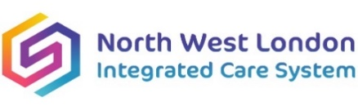 

***NHS North West London Integrated Care System Colleagues***

***You are invited to join a***

**Safeguarding Children Training Level 3**

**Date and time**

**29th October 09.30-16:30**

**Online training**

**Course Content/ Learning Objectives**

* Child abuse and complex presentations
* Contextual Safeguarding
* Parental/Carer risk factors
* Risk assessments
* Referral pathways, and escalation
* Multi-agency working
* Learning from Serious Safeguarding Review
* Roles and Responsibilities

**Who is this training for?**

* Clinical staff working with children and young people.

**Booking Information -Limited to 150**

**Booking closes 72 hours before the course, so book early to avoid missing out!**

**Please email:** [**nhsnwl.safeguardingtraining@nhs.net**](mailto:nhsnwl.safeguardingtraining@nhs.net)

**Booking details to include: Full Name, Role, Workplace Address/Trust, Email (work email only) and Telephone Number.**

**Training link will be circulated nearer the date.**

**Strict 48-hour cancellation policy.**